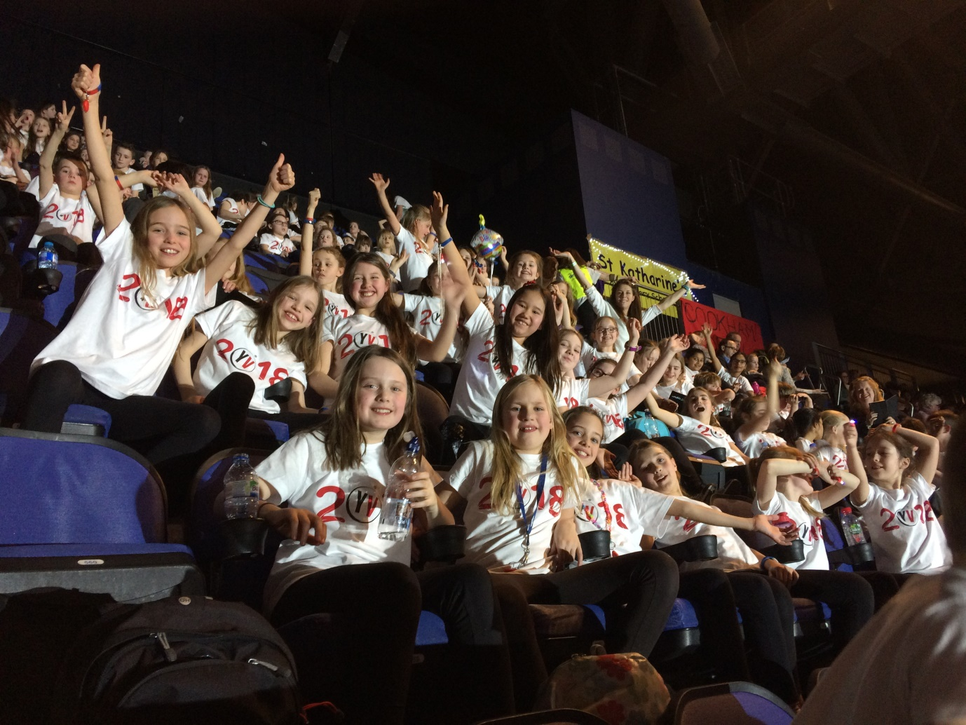

Cookham Dean Choir at 02

1st February, Cookham Dean Primary School Choir were part of an 8000 strong children’s choir at the 02. The children have been rehearsing since September, giving up lunchtimes and playtimes for extra rehearsals as well as learning lines and practising at home. Some songs were popular songs but others had been specially written for the occasion. The children joined other children from around the UK to perform to their parents along-side well-known names in the pop industry. ‘It was an energetic celebration of togetherness’ said headteacher, Fenella Reekie. ‘And a wonderful experience for the children which I am sure they will never forget.’

