
Cookham Dean Primary School
SMSC Calendar
2025-2026
This is an overview of the events we have planned for the year
Autumn
Date | Event | Event details | Aim | School Lead
14th October | Harvest  Whole school | We will celebrate Harvest Festival at St John the Baptist. The service will be led by our Year 6 . We will be collecting foodstuffs for Maidenhead Foodshare to support those who cannot feed their families.  | To consider those who are less fortunate than ourselves  To make a contribution to our local community  To share in a whole school act of worship and thanks with friends and families of our school | Year 6
21st September | World Gratitude Day | Children to write a gratitude diary for that week – remind us all of the things we have to be grateful for | To improve mental wellbeing for all | Emotional Wellbeing ambassadors
26th September | MacMillan Coffee  School Council | We will be asking parents to join us in raising money for MacMillan Cancer Support by holding a coffee afternoon on Friday 26th September.   | To consider those who are ill with cancer or who are affected by this illness as a family | School prefects
October | Black History Month  Whole School | Theme for this year is ‘Standing firm in power and pride. | To ensure that all children are included in all things irrespective of race, religion, gender. | History Lead
Friday 10th October | World Mental Health Day | The theme for this year is ‘It is time to prioritise mental health in the workplace’. We will be asking all children and staff to wear yellow to show that we are not alone | To raise awareness of positive mental health in our children – particularly on the back of covid | PSHE Lead/EWB ambassadors
Monday 10th November | Remembrance | At school we will hold our own Remembrance Service in honour of those who lost their lives fighting for their country. We shall be selling poppies in school in preparation for the day . At 11am we will observe a minutes silence and reflect on our own thoughts and feelings   | To learn about the reasons behind remembrances  To give thanks to those who gave their lives and be thankful for what we have. | Headteacher Whole School
Friday 14th November | Children in Need | The theme is Be Spotacular. The school council will decide how they would like to raise money.   | To take part in a national fundraising event  To consider those who are less fortunate than ourselves  To understand the power of community spirit | School council
10th – 14th November | Anti-bullying week | This year’s theme is ‘Power for Good . Children will be engaging in a range of activities during the week. They will explore what bullying is, what is looks like and what we can do if we see it happening or it is happening to us.   | To reinforce our anti-bullying ethos.  To help children and young celebrate what makes them, and others, unique and help them understand why it’s important that every child feels included in school  To reinforce the value of respect and to understand how to show respect to others (face to face and online)  To support children to understand that we are all different but all equal | PSHE Lead/EWB ambassadors
December | Visit to Old Peoples Homes | Children will visit Elizabeth House to deliver Christmas Cards, have lunch with the elderly and sing carols  Choir will visit Harwood House to sing Christmas Carols to the residents | To understand what it is like to be elderly and be able to share experiences  To think about people other than ourselves | Headteacher
December | Advent/Christmas  Pupils4Praise | Our Christingle service with year 3 and 4 will start Advent.  The whole school will learn about the Christmas story through our collective worship. Our carol service will be held at St John the Baptist. | To reflect upon and understand the Christmas story. | RE Lead/Headteacher/Year 3 and 4.

Spring
Date | Event | Event details | Aim | School Lead
6th February 2025 | NSPCC Assembly for Number Day | Part of the Speak Out Stay Safe campaign, children will raise money for the NSPCC as well as being made aware of the work of the NSPCC and to raise money  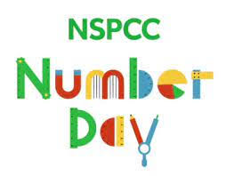 | Raise awareness of the support available for children experiencing abuse.  Raise money to support the NSPCC | Maths Lead/PSHE Lead/EWB Lead
10th February | Safer Internet Day  Digital Leaders |   Safer Internet Day encourages everyone to promote a safer and more responsible use of online technology and mobile phones. The theme for the day is ‘Together a better internet’. The children will take part in a range of awareness activities appropriate to their age group and explore how to keep themselves safe when using modern technologies | Explore ways to keep safe using modern technologies  Learn what to do when something unsafe is happening  Enjoy using technology | Computing Lead with Digital Leaders
21st March 2025 | Down Syndrome Awareness Day | World Down Syndrome Day 2026 (WDSD) is a worldwide event to raise awareness of Down syndrome. It's also a day to acknowledge and celebrate the lives and achievements of people with Down syndrome. Children are asked to wear crazy socks to remind children of the extra chromosome that Downs children have.   | This day helps to combat stereotypes and misconceptions about Down syndrome and educate people about the condition | SENCO
March 2025 | The Big Read  Librarians | The festival of reading takes part in Maidenhead culminating in World Book Day on 5th March. We will have visits by an author to inspire the children as well as workshops for parents. Vocabulary will be our theme this year and we will hold our own vocabulary parade. We want to inspire the children to enrich their vocabulary and we would like the children to dress up as a word from their favourite book. The children will take part in many reading activities that week across the whole school.   | Raise the profile of reading for fun  Explore books that children would not normally choose  Have the opportunity to learn new vocabulary | Reading Lead and Book Worms
TBC | Comic Relief | We will be having a non-uniform day to raise money for Comic Relief. The children will also be taking part in a range of fun and funny activities to raise money | Come together as a school to raise funds to help vulnerable people  Raise awareness of the importance of keeping mentally well. | School Council
16th -20th March | Neurodiversity celebration week | To help the world to understand, value and celebrate the talents of neurodiverse minds.  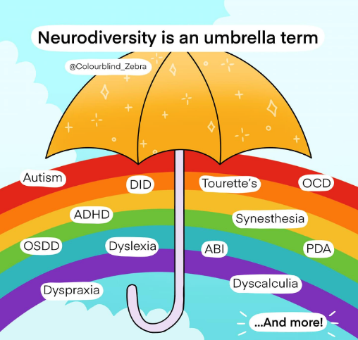 | To raise awareness of neurodiversity amongst parents and children in school | SENCO
March | Visit to old people’s home  Rotakids | Rotakids will make Easter cards and small gifts to take to Elizabeth House. They will share a lunch with the elderly residents. | To engage with the local community  To share expriences with the elderly | Headteacher
April | Easter  Year 6 | The school will learn about Lent and the Easter Story. Children will be encouraged to follow the Lent Calendar to think and pray for others. Our daily collective worship will focus on the key events before, on and after Easter Sunday.  Our Easter Service will take part at St John the Baptist.  | To understand what happened at Easter and why it is the most important time of year for Christians. | Re Lead/Headteacher

Summer
Date | Event | Event details | Aim | School Lead
10th to 16th May | Christian Aid Week  P4P | Children are asked to raise money for a global project | To raise awareness of global plight | RE Lead
8th June to 12th June | Healthy Schools Week  Sports Ambassadors | Children take part in a wide variety of sporting activities as well as there being a focus on healthy minds and healthy eating every afternoon. | To introduce children to non-traditional sports  To ensure that children understand the importance of looking after their bodies  To share experiences outside of the traditional curriculum | PE Lead/PSHE Lead/Headteacher
13th July | Poetry Competition  Librarians | Our annual poetry competition where the children have the opportunity to learn a poem and perform in front of their class. The winner of the class entries will be put forward to the school final   | Raise the profile of poetry across the school  Encourage children to express themselves  Encourage children to develop their social skills and confident in speaking in front of others. | English Leads
8th July | Musical Soiree | Children who have learnt a musical instrument in school are asked to perform to an audience of parents. | To raise pupils’ confidence to perform | Music Lead

