Try out Joe Wicks’ (known as the Body Coach) home workouts!  Simply follow the link and click on ‘kids workouts to do at home’ and have some fun!  https://www.youtube.com/user/thebodycoach1  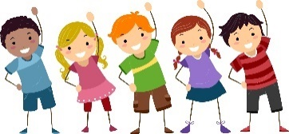 | Do you fancy getting active and having fun whilst learning?  If so, try BBC Supermovers!  Follow the link below and choose from a range of stimulating learning songs and dances that you can join in with.  https://www.bbc.co.uk/teach/supermovers  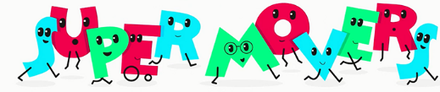 | Another fantastic way of getting up and moving is through imovers! Again, join in with some fun, fantastic dances and feel amazing after.  https://imoves.com/the-imovement  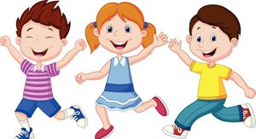
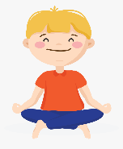  How about some lovely, relaxing yoga and mindfulness?  ‘Cosmic Kids’ offer fun yoga, mindfulness and relaxation videos on Youtube. Follow the link below:  https://www.youtube.com/user/CosmicKidsYoga | ‘Go Noodle’ is a fantastic, high energy website that allows children to dance and sing along to a range of videos.  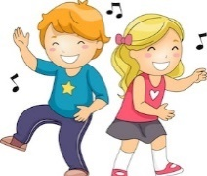  If you’re up for some go-noodling fun, then follow the link:  https://family.gonoodle.com/ | Get creative! Why not create a kindness calendar with an act of kindness that you and your family/friends can do each day!  Have a look at an example below:  https://www.naturalbeachliving.com/april-random-acts-of-kindness-calendar/  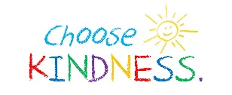
Here are some lovely mindfulness activities that the whole family can get involved with:  https://positivepsychology.com/mindfulness-for-children-kids-activities/  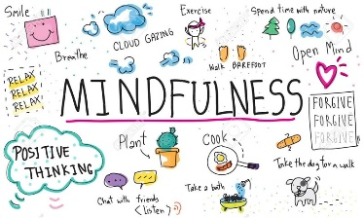 | Why not let your inner artist self shine and get involved with some fabulous arts and crafts activities? Below are some great ideas:  https://www.happinessishomemade.net/quick-easy-kids-crafts-anyone-can-make/  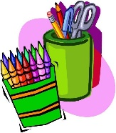 | Before you go to sleep, ask yourself:  - Who or what made you happy today?  - How did you make someone else happy?  - What did you learn today?  

